**Instructions: VIT-AP UNIVERSITY, ANDHRA PRADESH**

**Lab Sheet 5 : Animation and FABs**

**Academic year:** 2022-2023  **Branch/ Class:** B.Tech

**Semester:** Fall  **Date: 12-10-2022**

**Faculty Name:** Dr.K.Rajesh  **School:** SCOPE

NAME: REGNO:

**\*\*\*\*\*\*\*\*\*\*\*\*\*\*\*\*\*\*\*\*\*\*\*\*\*\*\*\*\*\*\*\*\*\*\*\*\*\*\*\*\*\*\*\*\*\*\*\*\*\*\*\*\*\*\*\*\*\*\*\*\*\*\*\*\*\*\*\*\*\*\*\*\*\*\*\*\*\*\*\*\*\*\*\*\*\*\*\*\*\*\*\*\*\*\*\*\*\*\*\*\*\*\*\*\*\***

* Fill your Name and REGNO.
* Complete the program, add the code java and XML, input and output Screenshots after the question on the same document.
* Save this File name with your **registerno**_**lab5**

**eg 18ABC1234_LAB5.pdf**

* Upload it in assignment ->LAB5 in MS TEAM

1.Design a Floating action button demo. Initially only the pink button should display when the the pink button is click the rest of the three buttons should be displayed. When each button is clicked then taost message should be displayed. When the pink button is pressed again the three buttons should hide.

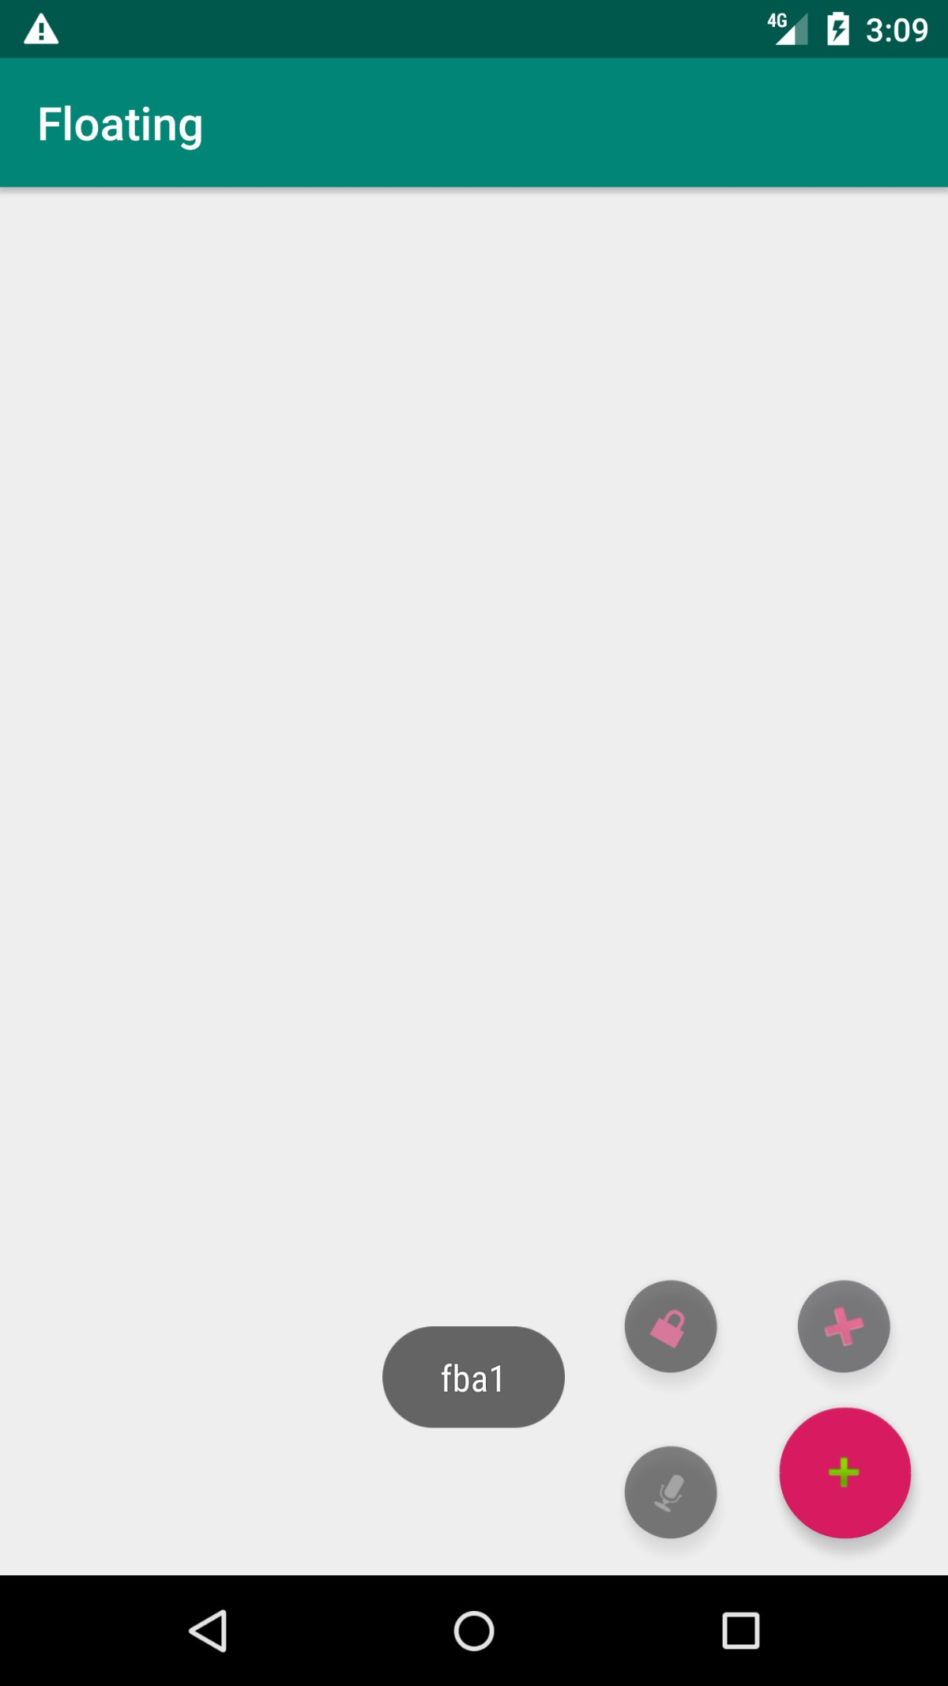

2. Design an App to scale one image big and one image small and vice versa.

